Accessible Information Needs Questionnaire
At the Reddish Family Practice we want to make sure that we give you information in a way that is clear to you, and to have on record any communication needs you might have.
The NHS Accessible Information Standard aims to ensure those patients and their carers who have a disability, impairment or sensory loss can receive access and understand information, and that they receive professional communication support if they need it.
This questionnaire has been designed to give you the opportunity to inform us if you have any difficultly in reading or understanding the information that we send you and record your preferred way of communicating with the surgery and its staff.
 | Your details | Please fill in the boxes below
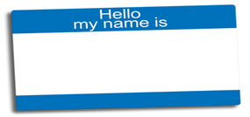 | Your full name
 | Your date of birth
 | Today’s date

 | Question | Please tick
1. | Do you have any communication or information needs which are related to a disability, impairment, sensory loss or learning disability? | Yes
 |  | No
2. | When we write to you or contact you, do you need us to communicate in a particular way? | Yes
 |  | No

If your answer is NO to questions one and two above, please sign and date the form and return to the reception staff. If you have answered YES , please complete the rest of this form overleaf.
 | Question | Answer
3. | What disability, impairment, sensory loss do you have that affects your communication or information needs?

Please choose your preferred method for us to contact you with information, such as a letter to invite you in for a flu vaccination:
 | Method or Format | Please tick or provide details
Text
(please confirm the number)
 | Large print
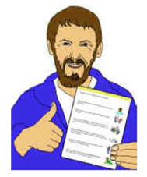 | Easy read document
Other
(please tell us what this is)

 |  | Question | Please tick
4. |  | When you come into surgery for an appointment do you need a British Sign Language interpreter? | Yes
 |  |  | No
5. |  | Can we share this information with other health and social care providers (for example if you needed to attend an outpatient clinic at hospital)? | Yes
 |  |  | No

Thank you for completing this form, please return it to the reception. We will update your patient records so that every time you book an appointment or we need to contact you we will do so using your preferred method.
You can find more information about the NHS Accessible Information Standard on NHS England’s website https://www.england.nhs.uk/ourwork/patients/accessibleinfo/
or on the surgery’s website: https://www.thereddishfamilypractice.nhs.uk/

Please return this completed form to reception.

